Visualizing shipbuilding features through textual evidence: the case of the 19th century brigs

Andri Evripidou, ΜΑ
Master’s Programme in Field Archaeology on Land and Under the Sea,
Department of History and Archaeology, University of Cyprus

Nicosia, January 2021

- Introduction
This thesis was an attempt to gain insights into the vernacular shipbuilding of the 19th century in the eastern Mediterranean, through the examination of historical archival sources concerning brigs.

During the 19th century, maritime trade and shipping in the Mediterranean were organized through international merchant networks that concerned mainly bulk cargo transportation (Harlaftis 2001: 85 – 86).` The Aegean islands together with some mainland harbours were involved in these networks and maintained their own shipyards. The most active shipbuilding center of the Aegean was Ermoupolis, the capital of the island of Syros, which became an international maritime shipping center after the Greek revolution of 1821 (Delis 2010: 344). Brigs were the predominant ship type constructed in Ermoupolis shipyards and consisted the main ship type of the Greek-owned merchant fleet. Therefore, it became the focus of this study.

Historical and archaeological literature provides important information about shipbuilding, and brigs construction in particular, during that era. Illustrations of brigs on paintings are common, but material evidence of them is limited to ships’ figureheads and other sporadic parts exhibited in museums. The rarity of excavated shipwrecks adds to the lack of plans and other visual representation of brigs constructed in the Aegean, which have resulted in many gaps in knowledge of this key type of ship.
Given all the above, the main goal of this research was a technical analysis of shipbuilding contracts for brigs, built between 1832 to 1857 in Ermoupoli’s shipyards. To this end, digital visualisation was used to gain meaningful knowledge about the brigs’ architectural system.
The main objectives can be summarized as follows:
- Analysis of nine shipbuilding contracts of brigs.
- Digital documentation of a brig model.
- Digital partial reconstruction of the nine brigs under study.

- Methodology
To understand and recognize the information recovered from archival sources, it was first necessary to examine data derived from previous research about 1) maritime trade, 2) shipbuilding, and 3) brigs during the 19th century. The next step was to tabularize all the valuable retrieved data from shipbuilding contracts concerning brigs’ components’ measurements or positioning. During the process of graphical and mathematical analysis that followed, a challenge was faced related to the shipwrights’ terminology, some writing mistakes and the shipwrights’ own expressions. Since brigs’ plans of the Aegean region were nonexistent, for the brigs’ components reconstruction I have decided to use the hull lines of a famous in Greek history brig, ARIS (1818), through the photogrammetrical recording of its ship model, (Konstantinidis 1954; Adamopoulou 2014; Nikolaou 2014). These hull lines were used as the reference point for the reconstruction of all the examined ships' data under study.

- Brigs of the Eastern Mediterranean
Brigs were characterized by their rigging type. They were merchantmen with two masts and square sails, influenced from North-European shipbuilding traditions. Paintings of showed that their sails’ number changed throughout the 19th century, varying from three to five, while the predominant number was four on each mast.
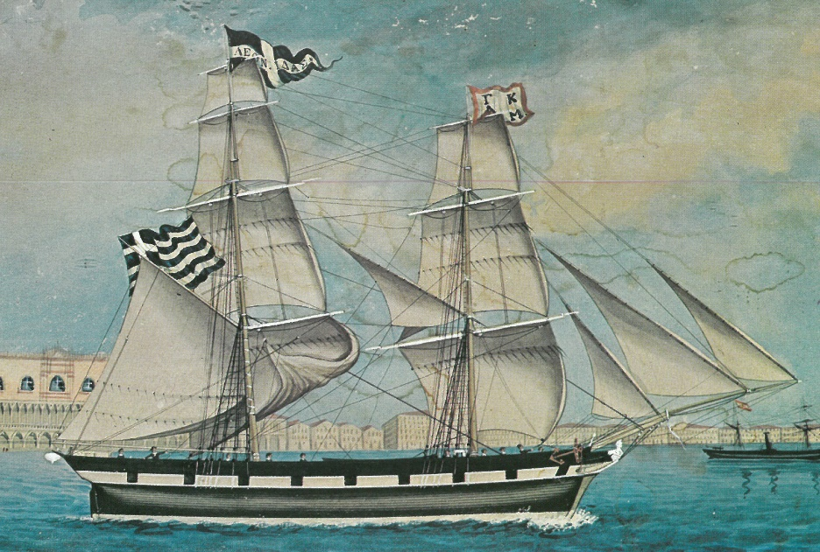
Brigs’ rigging could be applied in several hull types. During the first half of the 19th century, the most frequently attested in Greek paintings were depicted with inclined transom. This type of hull did not survive during the second half of the 19th century and its name remains unknown (Damianidis 2014: 329 – 330) (Fig. 1). It resembled the ‘Karavoskaro’ (Kαραβόσκαρo in Greek), a type with counter stern.
Figure 1: The brig LEONIDAS whose hull represents karavoskaro type with inclined transom instead of counter stern. Painting by Gie Luzze, Venice, 1861 (Tzamtzis 1972: Fig. 68)

Early brigs were characterized by the gun ports on the ship’s bulwark side, an S-shaped bow and an Ψ-shaped transom at the projecting stern (Fig. 2). From the 1850s onwards, the morphological characteristics of brigs changed. Following the international trends, they were constructed smaller, cheaper, without false gun ports, and with less decorations. The double curvature (S-shaped) of the stem post became hollow and a counter stern replaced the transom (Delis 2014: 54) (Figs. 3,4). The shape of the ship’s body varied and cannot be accurately characterized (Damianidis 2014: 322, 328) (Fig. 5). We could describe it, however, as a cargo ship of a full body.
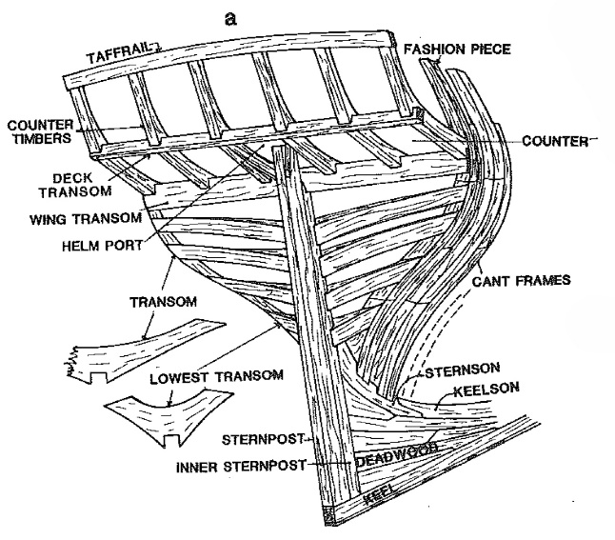 | 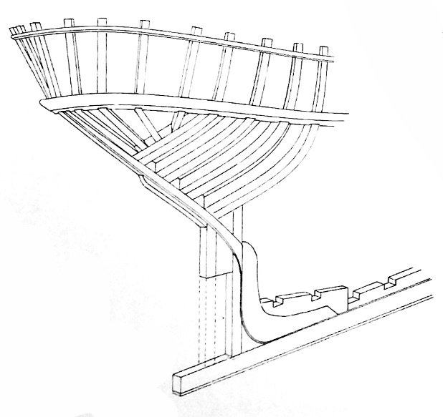
Figure 2: Stern framing of an 18th century brig (Steffy 1994: 295, Fig. G-14a) | Figure 3: Stern framing of a 20th century karavoskaro (Damianidis 1998: 194, Fig. 237)

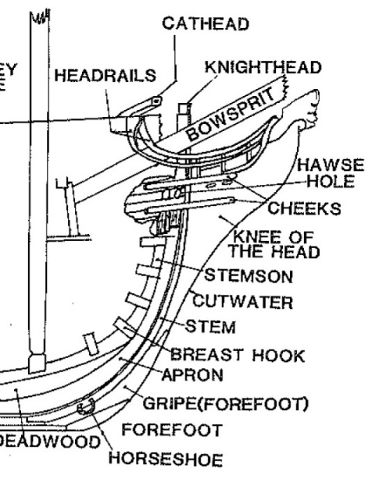 | 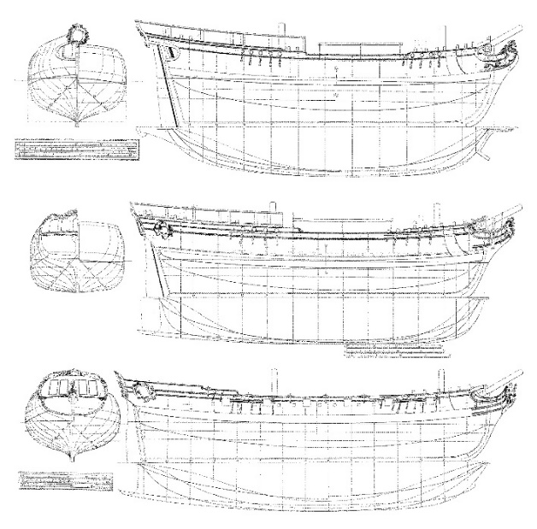
Figure 4: Bow structure (Steffy 1998: 284, Fig. G-3) | Figure 5: Hull lines of ships carried brig rigging (Damianidis 2014: 322)

- Visualization of shipbuilding features
Before and after a 19th century ship's construction, several types of contracts were created such as shipbuilding contracts, contracts of raw material purchase, and title deeds. The shipbuilding contracts, which is the focus of this study, constitute the first stage of the shipbuilding process; they set the guidelines and terms of the ships' construction and define the sense of trust between the owner and the shipbuilder.
The longest part of the contracts was the technical description of the new ship with details about structural elements. For this study nine contracts were selected: eight of them were provided by the General State Archives, the Cyclades' Prefecture, Syros, and one belonged to the private collection of Spyros Manousakis (Tzamtzis 1987: 28 – 30).
As with all skeleton first built vessels, shipbuilding process of Aegean sailboats was divided in two phases: the frame construction and the planking installation. Ships’ structural components are distinguished in two categories: the transversal elements used for the hull’s shaping, and the longitudinal reinforcement elements responsible for the ship’s durability and reinforcement (Damianidis 1998: 214-215; Pomey 2011; Boetto & Poveda 2018). The main information described about all these components in the contracts’ technical analysis were:
- their cross-section dimensions,
- their number, and
- their position in the ship’s structure.

These data, however, were not indicated for all components and sometimes the way they were described was insufficient. The comparative analysis of the process, as described in the contracts, led to the following summary, for each one of the brigs’ key structural elements:
      - Keel: when shipwrights referred to it, they usually meant one timber and not one structure comprised of scarf jointed pieces. Moreover, a false keel was fastened below the keel for extra protection and, usually in bigger ships, a rising wood was put on top of the keel for better adjustment of the frame timbers. The molded side of its cross section was bigger than the sided.
      - Stems and sternposts have the same cross-section dimension with the keel.
      - Frames: their dimensions given in the contacts concerned double framing. The in-between distance of most frames was 15.2cm while their number was rarely mentioned. However, if we know the dimensions of the frames’ sided cross-section, the distance between them, and the keel's length, then their number could be approximately estimated. (Fig. 6).
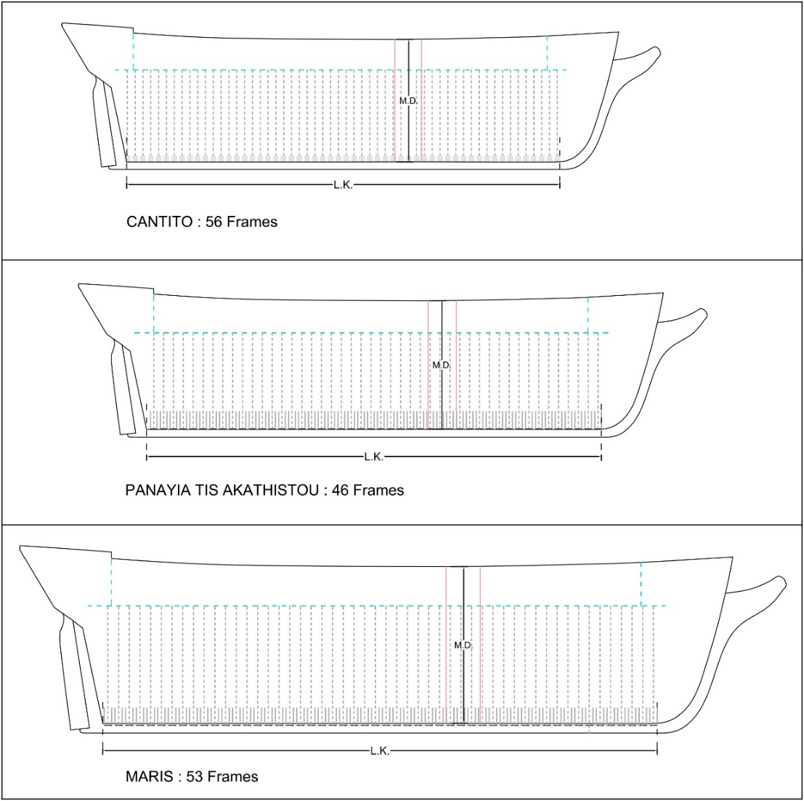
Figure 6: Drawings indicate the frames’ number after three study’s estimation. The number was estimated according to the L.K.

      - Keelson was composed of one board or two scarfed shaped timbers, it is bigger than the keel, and mainly squared shaped (Fig.7)
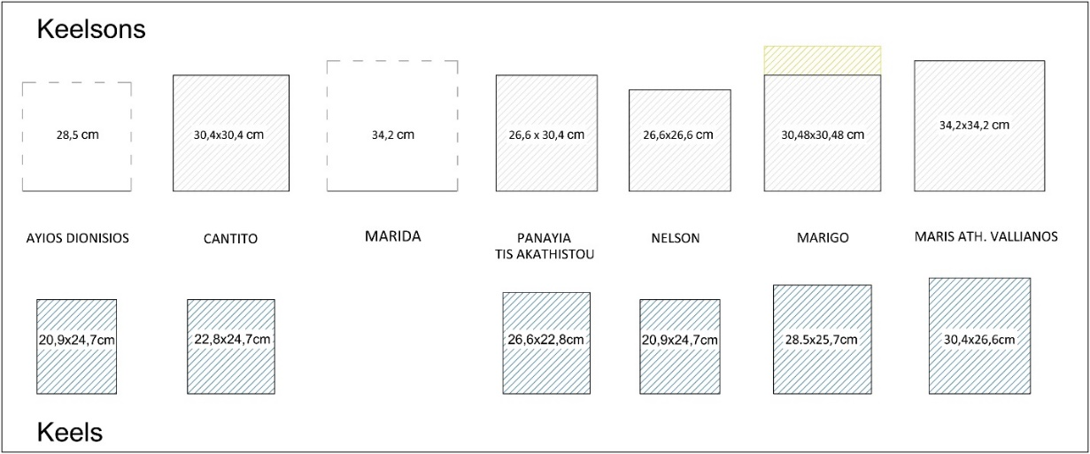
Figure 7: Keelsons’ shape and size compared to the keels

      - The footwales (stringers) are thicker than the rest of the ceiling planks and their number varied from 4 to 6 on each side. They were probably divided over the ship’s sides, but no details were specified.
      - Shelf clamps were positioned below the main and lower decks. Larger ships had two or three shelf clamps under each deck and those of the lower deck were slightly smaller than those of the upper (main) deck.
      - Clamps, usually positioned below shelf clamps have a complementary role, and their thickness was similar to this of footwales.
      - Some of the contracts referred to another longitudinal element, the "gyali koutouki" which remains an unknown term. It is located under decks, extending from the stern's bulkhead to the bow's stem post. It was usually notched and attached on the beams' hanging knees. Its shape and size are similar to the shelf clamps.
      - Beams and ledges or half beams: The lower deck beams were bigger in cross-section than the upper deck ones, but both were nearly square-shaped. According to their data analysis, ledges’ number and pattern can be approximately estimated if we know their cross-section measurements, the beams number, the in-between distance of ledges and the keel’s length (Fig. 8). According to this analysis, both the positioning and dimensions of ledges and beams were related to those of the frames (Fig. 9).
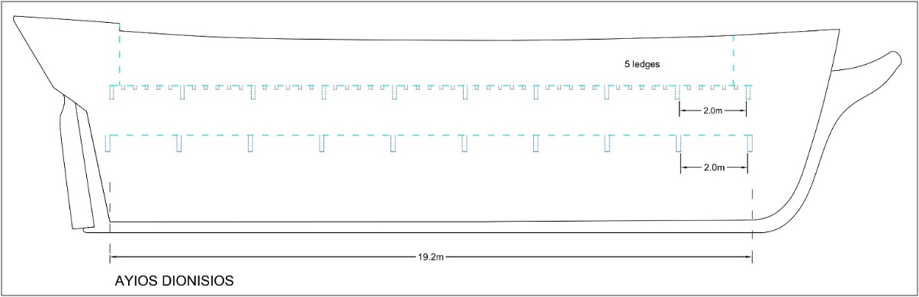
Figure 8: The drawing represents the estimated number and pattern of AYIOS DIONISIOS beams and ledges contract data.
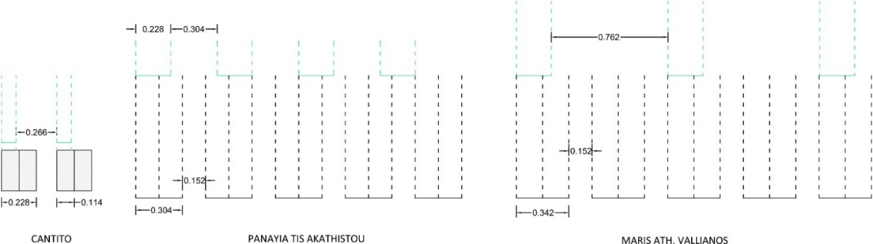
Figure 9: The frames’ and beams’ (green color) size and in-between distance relation

      - Planking: Contracts refer to the first planking timbers, and the wales or external shelves, whose number varied from 6 to 10 on each ship's side. Ceiling planks are installed over the side of the ship, usually up to the lower deck and their thickness is smaller compare to deck and hull planking (3.8 – 5-7cm). The thickness of deck and hull planking (4.75 – 8.55cm) is the same and their length is rarely indicated.
      - The examined brigs' bulwark is composed of the gunwale (κουπαστή*), the lower gunwale or waterway (τρυπητή*) and the plank sheer (ζωνάρια*). It is described as double or single, meaning that planks were installed on both sides or only the outer.
      - Two important conjunction elements of ships are the breast hook knees and the knees. The only data recorded concerning them is their number and position (bow or stern). Knees reinforced the junction of two surfaces of different planes, and they were often mentioned in the contracts in combination with other parts of the vessels.
The ship's division elements (Fig. 10), their superstructures, and equipment (Fig. 11) are only briefly mentioned in the contracts. The brigs’ interior was divided by bulkheads, in the middle of the hold, and between the hold and the captain’s cabin to the aft part and the sailors’ room to the fore of the vessel. Some of the ships’ superstructures and equipment are also mentioned: catheads, canopy, skylight, galley, belfries, hatchways, channels, rudder, wheel or the tiller, bits, hawses, catheads, figureheads, capstan and the windlass.
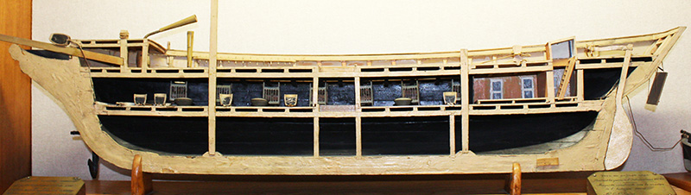
Figure 10: The interior arrangement and subdivisions of a naval artillery brig model constructed in 1907, Piraeus, Greece and now is exhibited at the National Historical Museum in Athens (Photo by the author)

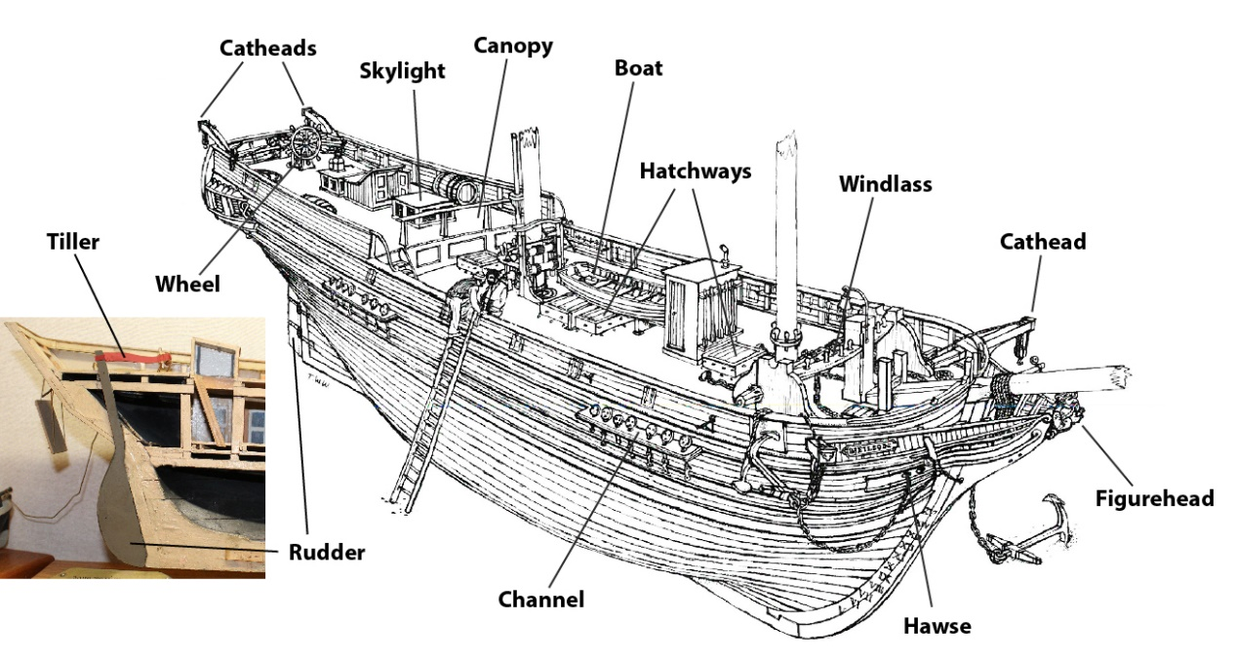
Figure 11: The equipment and superstructures as indicated in the text on a drawing of an American brig named Neilson (based on MacGregor 1973: 76); A detail of the rudder and the tiller of the brig model in Figure 10.

Among all the studied cases, the most comprehend information came from the contract for a brig named CANTITO. Thus, it became possible to reconstruct its transversal section and a 3D section of its mid-part (Figs. 12, 13).
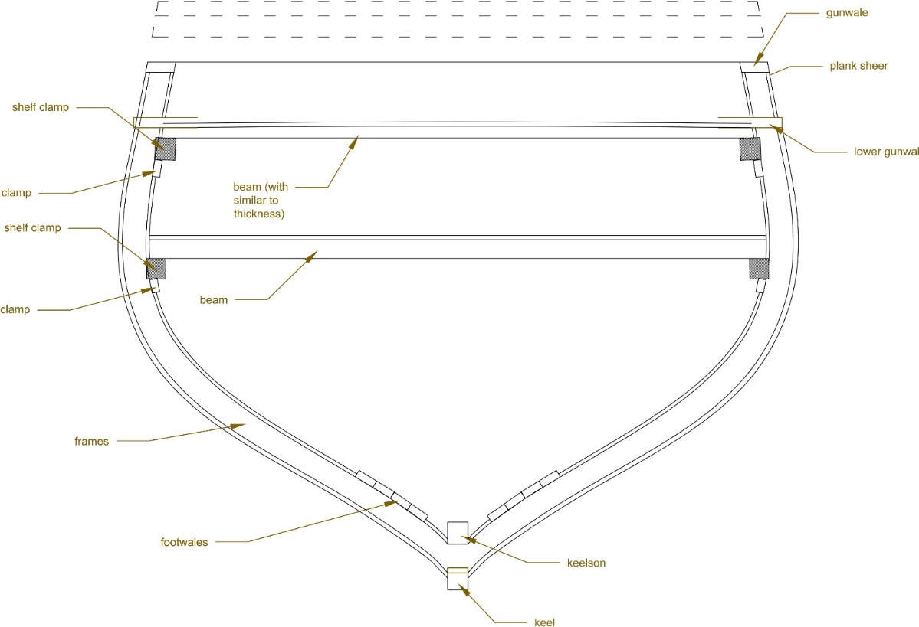
Figure 12: CANTITO’s mid-frame section, indicating the transversal and longitudinal ship’s structural components

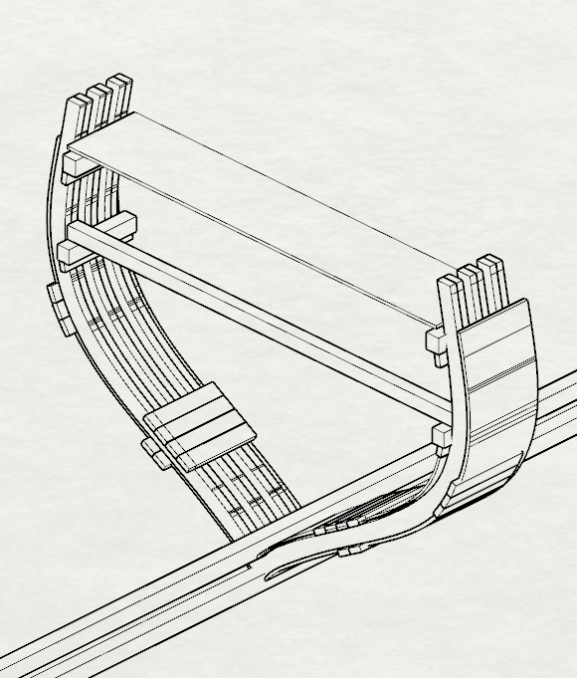
Figure 13: CANTITO’s mid-part 3D section, indicating the transversal and longitudinal ship’s structural components

- Conclusions
The technical analysis of a shipbuilding contract can only reveal specific information about the ship’s structure. However, the combination of the information derived from each document together with data obtained from previous research on the topic, can lead to a more comprehensive approach. Thus, the fact that the dimensional and positioning data of transversal elements - frames and beams – were more specific than the longitudinal, is indicative of the conceptual phase of the construction. Quantities of parts mainly concerned longitudinal reinforcing elements, such as the keel, keelson, shelf clamps and footwales; still their positioning could only be approximately estimated.

These facts generate questions regarding the shipwrights and the owner’s perception of the ship’s final structure. Shipwrights were able to perceive the shipbuilding contracts as a way to define the number and size of timbers required for the ship’s construction. More specifically, the form and the size of the ship was defined by the keel and the frames (basic dimensions). Therefore, these components probably were enough for the owner’s ship perception. The number of frames was not initially specified because what mattered for the ship’s integrity was their construction details. Their number was flexible and was supposed to be finalized according to the final length of the ship. The exact positioning of the longitudinal reinforcing elements was not necessary to be predefined, since their actual role depended on their thickness which indicated the strength of the ship and its ability to resist in water or wind strains. Whatever was the perception of the owners and shipwrights, however, the shipbuilding contract reflects the initial conception of the ship. Its realization was a process conducted under empirical knowledge and the final structure was only perceived in the mind of the shipwright during its construction (Fig. 14).
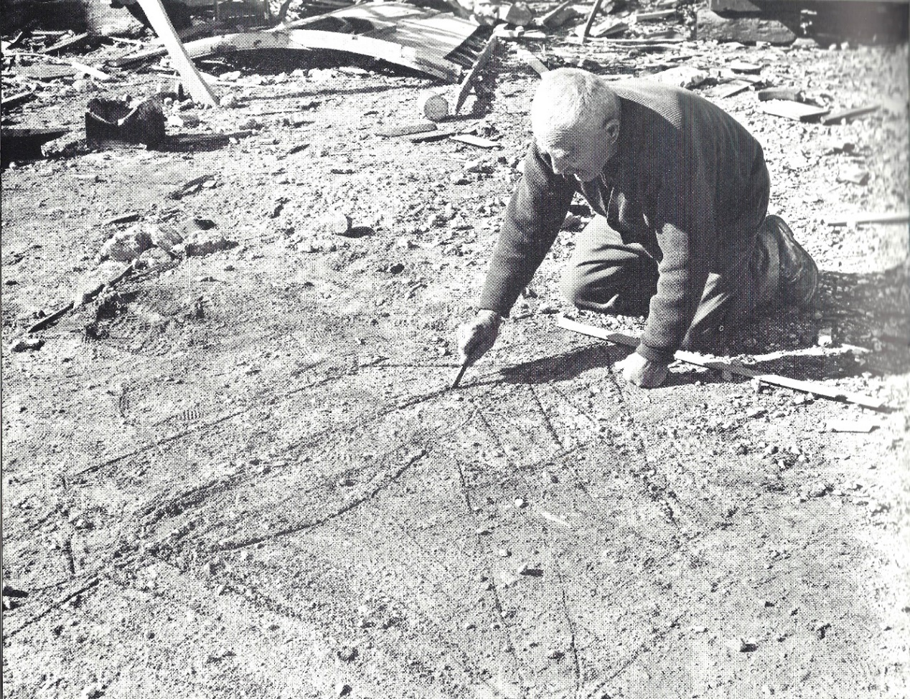
Figure 14: Yero-Glaros, an old boatbuilder, drawing the design for a new vessel in the sand of the boatyards at Lafassi, Kalymnos, Greece (Tzamtzis 1972: Fig. 27).

Approaching historical evidence through technical disciplines, offers a multidisciplinary point of view to the field of nautical archaeology, and sheds light on material aspects regarding historic shipwrecks. Therefore, the examination and visualization of more brigs’ contracts would be useful for future research, especially if they were grouped into categories concerning:
- ships constructed during different decades (technological changes)
- ships’ rigging equipment (number of sails and gear elements)
- ships with similar dimensions (particularities of the structure)
- ships constructed by the same shipwrights (shipbuilders’ knowledge)
- ships constructed for the same owner (owner’s needs)

Bibliography
Adamopoulou, Nt. (2014). “Άρης”: Το σύμβολο της Ελληνικής Ναυτιλίας (19^{ος} αιώνας) [“Aris”: The symbol of Greek Shipping] in K. A. Damianidis 2014 , pp. 320-330.
Boetto, G. and Poveda, P. (2018). Napoli A, un voilier abandonné dans le port de Neapolis à la fin du Ier siècle: architecture, fonction, restitution et espace de navigation, in G. Boetto et É. Rieth (eds.), , De re navali: Pérégrinations nautiques entre Méditerranée et océan Indien, Archaeonautica, 20 , pp. 19-56.

Damianidis, K. A. (1998). Ελληνική Παραδοσιακή Ναυπηγική [Greek Vernacular Shipbuilding], Piraeus Bank Group Cultural Foundation (PIOP), Athens

Damianidis, K. A. (ed.) Ναυς – Πλοία και Ναυπηγική στον Ελληνικό Κόσμο (Naus – Ships and Shipbuilding in the Greek world). Pireus Bank, Polaris
Damianidis, K. A. (2014). Το μπρίκι, ένας τύπος ιστιοφόρου της ελληνικής ναυτιλίας [The brig, a sailboat type of the Greek merchantmen], in Damianidis 2014, pp. 320-330, Piraeus Bank, Athens.
Delis, A. (2010). Ερμούπολη (Σύρος): το ναυπηγικό κέντρο της ιστιοφόρου ναυτιλίας, 1830-1880, [Hermoupolis (Island of Syros): the Shipbuilding Centre of the Sailing Merchant Marine, 1830-1880], unpublished PhD dissertation, Ionian University, Corfu.
Delis, A. (2014a). From Lateen to Square Rig: The evolution of the Greek-owned merchant fleet and its ships in the eighteenth and nineteenth centuries, The Mariner's Mirror, 100(1), pp. 44-58.
Harlaftiss, G. (2001). Η Ιστορία της Ελληνόκτητης Ναυτιλίας: 19^{ος} -20^{ος} αιώνας (A History of Greek-Owned Shipping: 19th-20th century). Nefeli, Athens.
Konstantinidis, T. (1954). Καράβια, Καπετάνιοι και Συντοφοναύται 1800 - 1830 (Ships, Captains and the Crew, 1800 - 1830), Athens.
MacGregor, D. R. (1988). Fast Sailing Ships: Their Design and Construction, 1775–1875, Annapolis.
Nikolaou, G. (2014). Τα ομοιώματα πλοίων της Επανάστασης του ΄21 από τη Συλλογή του Εθνικού Ιστορικού Μουσείου [The Greek Revolution ships’ replicas, from the Collection of the National Historical Museum], in N. Kastriti and R. Katsimardou (eds.) Τεκμήρια Ιστορίας – Μονογραφίες [History Evidence – Monographs], Historical and Ethnological Society of Greece, Athens, pp. 11-20.
Pomey, P. (2011). Defining a ship: architecture, function, and human space, in A. Catsambis, B. Ford, and D.L. Hamilton (eds.) The Oxford Handbook of Maritime Archaeology, pp. 25-46. Oxford
Steffy, J. R. (1994). Wooden Shipbuilding and the Interpretation of Shipwrecks, Texas.
Tzamtzis, A. I. (1972). Ships, Ports and Sailors, in St. Papadopoulos (ed.), The Greek Merchant Marine: (1453-1850), pp. 53-174, National Bank of Greece.
Tzamtzis, A. I. (1987). Μια ναυπήγηση πριν 150 χρόνια [A ship building 150 years ago], Nautika Chronika 1248/1007, pp. 28-30.

